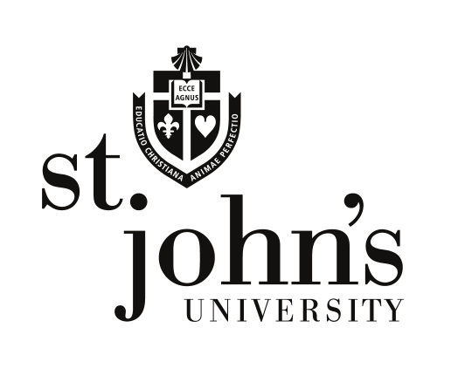

The Center for Labor and Employment Law

David L. Gregory
The Dorothy Day Professor of Law
Executive Director, Center for
Labor and Employment Law
Tel 718 990-6019
Fax 718-990-6649
gregoryd@stjohns.edu
St. John’s University
School of Law
8000 Utopia Parkway
Jamaica, Queens, NY 11439

January 10, 2014

Re: LABOR LAW SOCIETY GENERAL MEETING January 14

I have been completely swamped with resume/cover letter/job search appointment requests. I will be happy to meet with each person according to the following priority conditions.

First Priority students will be those who attend the General Meeting of the Labor Law Society on Tuesday, January 14, Room 2 M 08, 530 pm, AND AT THE JANUARY 14 MEETING submit to me in person by hard copy hand delivery their cover letter, resume, unofficial transcript, list of labor and employment courses previously taken/with grade and current semester list of courses. (Classes of 2015 and post must also provide a list of courses they intend to take in the summer 2014 session and 2014—15 academic year.) AND---recognizing that current students are often the best ambassadors, a draft one page letter you propose we send to prospective applicants. AND---your proposed dates and times for our forthcoming individual appointment beginning Thursday, January 16, 2014 at 1115 am. I am teaching 925—1050 am T and Th this semester and optimal appointment times will be 1-4 pm on T an Th.

It is imperative that you bring your computer to the Jan 14 meeting, in order to complete some resume/cover letter drafting exercises at the Jan 14 meeting.

First Priority student appointments will begin on Thursday, January 16, 1115 am. You will receive your appointment notice on January 15.

Best,
DLG
FYI, see attached

Labor law society general meeting January 14 2014

